Reading

Time: 45 minutes

Part 1

Read the text and decide which of sentences 1-10 are true (A) and which are false (B), according to the text.

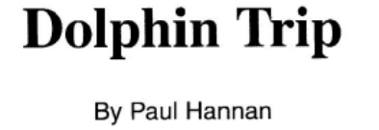
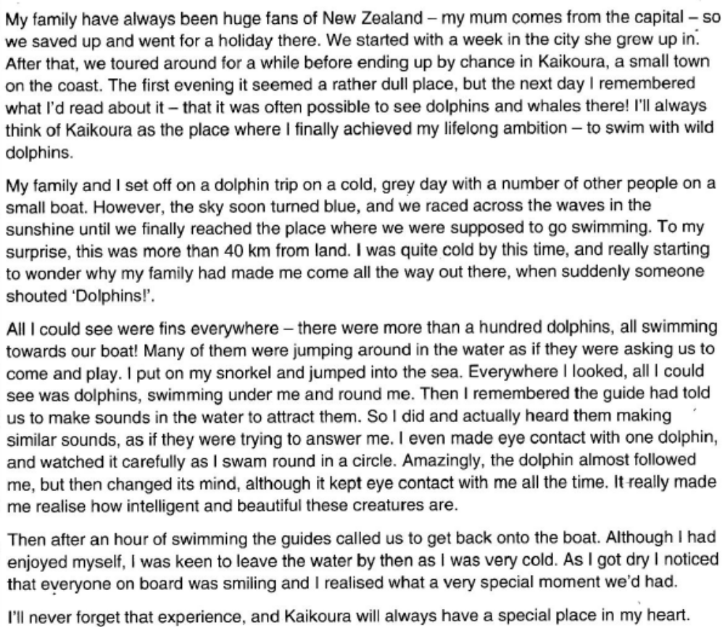

1. Paul has family connections with the place he first visited in New Zealand
A. True B. False

2. Paul and his family chose to go to Kaikoura as part of their tour.
A. True B. False

3. As soon as Paul arrived in Kaikoura as part of their tour.
A. True B. False

4. The weather got worse during Paul’s boat trip.
A. True B. False

5. Paul had expected to go swimming closer to land.
A. True B. False

6. Paul was beginning to feel unhappy about the trip until someone saw the dolphins.
A. True B. False

7. Paul believed the dolphins were inviting him to join them in the water.
A. True B. False

8. Paul felt that he had failed to communicate with the dolphins.
A. True B. False

9. One dolphin copied exactly what Paul did in the water.
A. True B. False

10. Paul was pleased when the guides finally called them back onto the boat.
A. True B. False

Part 2

Read the text and decide which option, A, B, C or D, best suits as an answer for the questions 11-15.

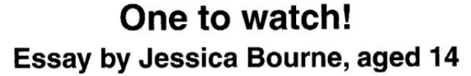
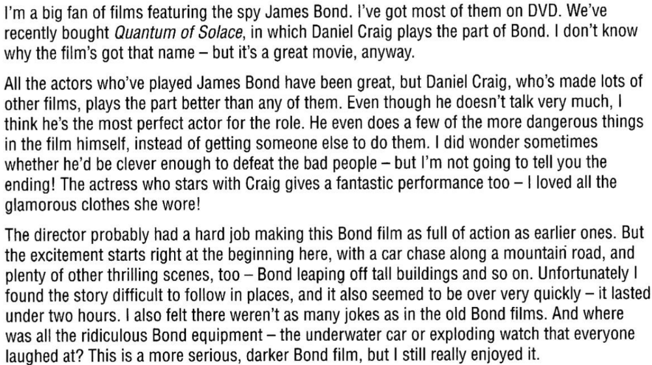

11. What is Jessica trying to do in her essay?
A. explain what first attracted her in her Bond films
B. tell readers about the Bond DVDs she owns
C. give a balanced view of a Bond film she has seen
D. describe how Daniel Craig got the part of James Bond

12. What can a reader find out from Jessica’s essay?
A. whether Quantum Of Solace is her favourite Bond film
B. what other films Daniel Craig has made
C. which other actors have played James Bond
D. whether she thinks Daniel Craig is the best James Bond

13. What does Jessica tell us about Craig in the new Bond film?
A. He performs some of the action scenes.
B. He wears some stylish clothes.
C. He is given a lot of lines to say.
D. He looks strong and fit enough to fight the criminals.

14. What is one problem with the film, according to Jessica?
A. It seems a bit too long.
B. It’s sometimes hard to understand what’s happening.
C. It has too much silly technology in it.
D. It has jokes that aren’t very funny.

15. Which of these might appear in a magazine review of the new Bond film?
A. It’s full of excitement, with Bond jumping across rooftops, so don’t be disappointed by the slow start.
B. The director wanted to move away from the last Bond film and include a bit less action.

C. I’m not sure the title tells you much… but be prepared to watch a rather different kind of Bond movie.

D. Daniel Craig performed well as James Bond, but the main female star was disappointing.

Part 3

Read the text and decide which of sentences 16-20 are true (A) and which are false (B), according to the text.

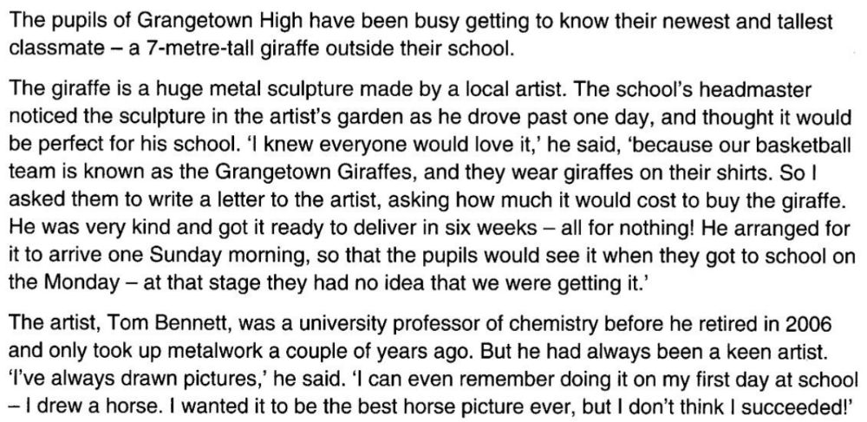

16. The headmaster wrote to the artist to ask about buying the sculpture for the school.
A. True B. False

17. The school got the giraffe sculpture free of charge.
A. True B. False

18. The schoolchildren were looking forward to the arrival of the giraffe.
A. True B. False

19. The artist Tom Bennett started making metal objects while he was working at a university.
A. True B. False

20. Tom thinks that he did an excellent drawing on his first day at school.
A. True B. False

TRANSFER ALL YOUR ANSWERS TO YOUR ANSWER SHEET

